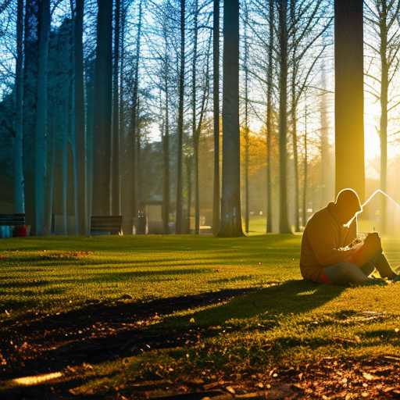
OVERCOMING SHADOWS v.1

Over time,
people will find that there are more and more things that they have in common

Then we can have
the spiritual revolution we all deserve -
even the ascent our souls demand

It is our hearts, not our technology,
that will form our new system
Our survival depends on it

We the People are human beings that refuse to live
under shadows, be they mental or institutional
Overcoming shadows is how we get a spiritual upgrade

